Categories

Must Haves
Sufficient Strength:
- Pass/Fail (Yield Strength > Load)
- Calculations (Assumptions are at Maximum):
Corrosion Resistance (Chemical Compatibility w Seawater)
- Pass/Fail (X >= B)
Necessary Temperature:
- Pass/Fail (30C > X > 2C)
  - With Air (30 C>x>-15C)

Wants
Categories:
Str-Weight Ratio - Strength of material based on specific quantity (avoids Strong but heavy designs)
Cost - Key Requirement is under 5k
Manufacturing Ease - Basic standard procedures will be prioritized. Along with ones that allow the creation for a complex geometry design, and minimize safety concerns as we don’t have the necessary skills.
Ductility - The ability of a material to plastically deform without breaking when tensile (stretching) stress is applied to it.
Young Modulus - measure of a material's stiffness, representing the ratio of tensile or compressive stress to the longitudinal strain it experiences
Coefficient of Thermal Expansion - CTE represents how much a material is going to shrink or expand under drastic change of temperatures.

Weights:
Manufacturing Ease/Repairability (30%)-
Cost (25%) - Constrained to <5k
Young Modulus (15%)-
Ductility 15%-
Coefficient of Thermal Expansion - 10%
Str-Weight Ratio (5%) -

Manufacturing Ease
- 1 (Not manufacturable)
  - Extremely high manufacturing risks
  - Required methods are unavailable under the laws of physics
- 2 (Possible but very difficult)
  - Very High manufacturing risks
  - Required methods are advanced/experimental & requires specialized tooling/extremely expensive
- 3 (Possible but highly limited)
  - High manufacturing risks.
  - Required methods are technically demanding, extremely time consuming, and extremely expensive.
- 4 (Manufacturable with significant challenges)
  - Moderate-high manufacturing risks.
  - Required methods are have expensive tooling/multiple special operations, and expensive
- 5 (Manufacturable with non-standard methods)
  - Moderate manufacturing risks.
  - Required methods are common, but need secondary operations, and are expensive
- 6 (Manufacturable with standard methods + extra procedures)
  - Low manufacturing risks.
  - Required methods are common and can be made with secondary operations, with average cost
- 7 (Manufacturable with standard method
  - Very low manufacturing risks.
  - Required methods are extremely common with standard tooling.
- 8 (Easily manufacturable)
  - Low manufacturing risks.
  - Relies on standard tooling processes and minimal secondary operation, and have low time consumption
- 9 (Very easy to manufacture)
  - Minimal manufacturing risks.
  - Relies on one process production and is extremely affordable.
- 10 (Highly manufacturable)
  - Lowest manufacturing risks.
  - Relies on simple processes with minimal cost and time consumption.
Cost:
- 10 - <$5
- 9 - $5 - $10
- 8 - $10 - $25
- 7 - $25 - $50
- 6 - $50 - $75
- 5 - $75- $100
- 4 - $100 - $250
- 3 - $250 - $500
- 2 - $500- $1000
- 1 - $1000 - $1500

Young Modulus
Source
Young’s modulus tells how much a material deforms elastically under load. A high value means that the structure will be stiffer.
I lowkey got the scale from perplexity…
- 1 (Extremely soft)
  - E < 1 GPa
- 2 (Very Soft)
  - 1–3 GPa
- 3 (Soft)
  - 3–10 GPa
- 4 (Extremely stiff)
  - ≥ 250 GPa
- 5 (Moderate stiffness)
  - 180–250 GPa
- 6 (Good Stiffness)
  - 30–60 GPa
- 7 (Very stiff)
  - 130–180 GPa
- 8 (Good impact resistance and toughness)
  - 30 ≤ E < 60 GPa
- 9 (Moderate stiffness that does not brittle)
  - 60–90 GPa
- 10 (High stiffness but does not brittle)
  - 90–130 GPa

Ductility
- 1 - <1% ex. Glass/Ceramics (Extremely Brittle)
- 2 - 1-3% ex.Brittle Resin (Very Brittle)
- 3 - 3-5% ex. Carbon Fiber Composites (Low Ductility)
- 4 - 5 - 10% ex. Thin Composites (Low-High Ductility)
- 5 - 10-15% ex. PC, Nylon Blends (Moderate Ductility)
- 6 - 15-20% ex. ABS (Moderate-High Ductility)
- 7 - 20-25% ex. Aluminum 5000’s & 6000’s (High Low Ductility)
- 8 - 25-30% ex. Average Steel (High Ductility)
- 9 - 30-40% ex. Stainless Steel (High High Ductility)
- 10 - >40% ex. Super Ductile Alloys (Legendary Ductility)

CTE (Coefficient of Thermal Expansion)
CTE source

- 1 (Unacceptable)
  - +130 x 10^-6 m/(m K)
- 2 (Extremely High)
  - 70 - 129 x 10^-6 m/(m K)
- 3 (Very High)
  - 41 - 69 x 10^-6 m/(m K)
- 4 (High)
  - 26 - 40 x 10^-6 m/(m K)
- 5 (Moderate High)
  - 17 - 25 x 10^-6 m/(m K)
- 6 (Moderate)
  - 13 - 16 x 10^-6 m/(m K)
- 7 (Low to Moderate)
  - 9 - 12 x 10^-6 m/(m K).
- 8 (Low)
  - 6 - 8 x 10^-6 m/(m K)
- 9 (Very low)
  - 2 - 5 x 10^-6 m/(m K)
- 10 (Extremely low)
  - < 2 x 10^-6 m/(m K)

Str-Weight Ratio
- 10 - >800
- 9 - 500-800
- 8 300-500
- 7 200-300
- 6 150-200
- 5 100-150
- 4 70-100
- 3 50-70
- 2 30-50
- 1 30

BWM Page
MATERIALS THAT INTERESTS ME (and have seen a lot in articles)
- PVC
- ABS
- POM
- HDPE
- Aluminum alloy 6000s and 5000s
- Fiberglass
- SS 316

Relevant characteristics to consider

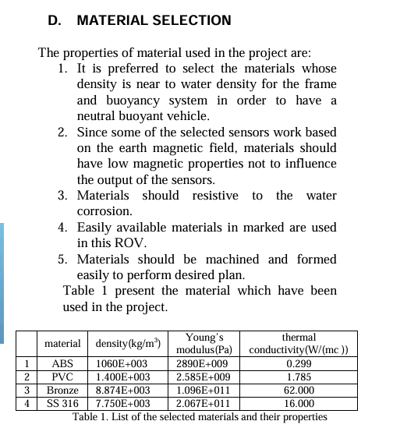
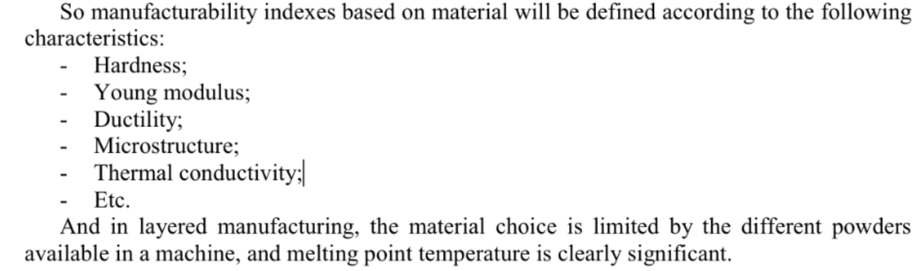

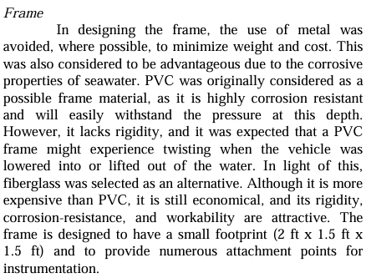]

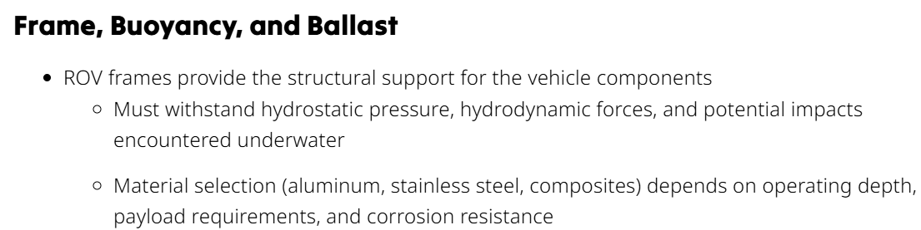

https://seamor.com/materials-for-rovs-top-5/ straightforward pros and cons for commonly considered materials

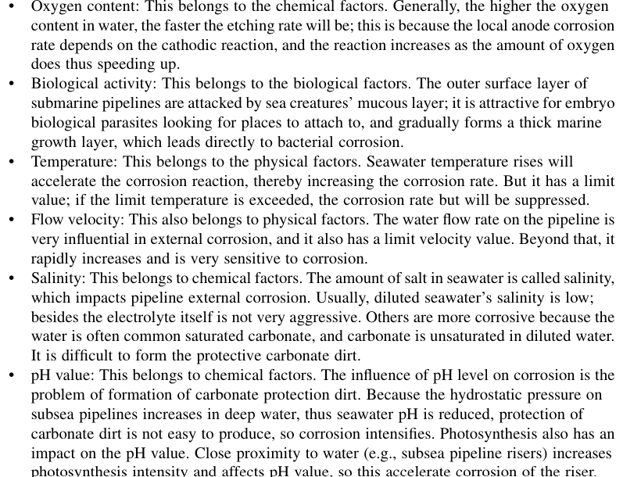
Factors affecting seawater corrosion
- pH of chlorinated water is around 6 - 8 (neutral)
  - Low pH -> increases risk of corrosion
- Cold water environments holds more dissolved oxygen, which increases the risk of corrosion
- Thermal contraction can stress materials
- Materials shrink at diff rates -> risks of leakage
  - Due to their CTE, materials might shrink under cold water. Tolerances and seal compression rations under cold conditions is NECESSARY TO CONSIDER
- Cold-water pitting -> a form of corrosion that creates small, deep holes in pipes, most commonly seen in copper pipes when they are exposed to cold water systems
  - metals corrode faster due to extra oxygen
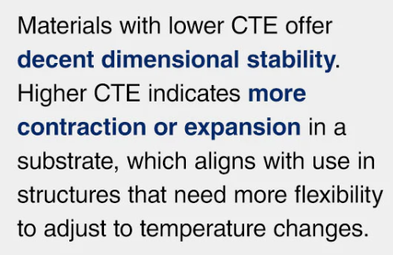
We do not want materials that become brittle in low temperatures. We need to consider their tolerances and seal compression ratios for cold water environments.
WE NEED LOW CTE MATERIALS

I ADVOCATE FOR THE UNIFORM USE OF ONE MATERIAL FOR THE WHOLE ROV MAINLY BECAUSE OF THE CTE MISMATCH THAT CAN HAPPEN UNDER COLD WATER ENVIRONMENTS.

Young modulus
Depends on water’s depth

Material Selection
Template
Yield Strength -
Corrosion Resistance -
Necessary Temperature -
Manufacturing Ease -
Cost -
Young Modulus
Ductility
CTE
Str-Weight Ratio -
Links:

HDPE
Yield Strength - 25 (Pass)
Corrosion Resistance - A (Pass)
Necessary Temperature - 40 - 60C (Pass)
Manufacturing Ease - Very Easy to Mill/Lathe & Cheap, but poor bonding/needs screws (8)
Cost - $0.95/kg
Young Modulus 1.5E (2)
Ductility 100-600 (10)
CTE - 1
Str-Weight Ratio - 25 /0.968 = 25.826 (1)
Links:
High Density Polyethylene (HDPE) - Properties
HDPE_Chemical_Compatibility_Resistance_Chart
https://www.societyofrobots.com/materials_hdpe.shtml
https://businessanalytiq.com/procurementanalytics/index/hdpe-price-index/

Polar Grade PVC
Yield Strength -
Corrosion Resistance - A^2 (Pass)
Necessary Temperature - -15C - 60C (Pass)
Manufacturing Ease - Cut with Saws/Drills almost no machining risk (9)
Cost - $10/kg (8)
Young Modulus - 3 (3)
Ductility 10(5)
CTE - 60 (3)
Str-Weight Ratio - 52 / 1.3 = 40
Links:
Polyvinyl Chloride (PVC) : Properties, manufacturing, Types, Processes, and Uses | TEAM MFG
PVC (Polyvinyl chloride) Chemical Compatibility Chart
Understanding PVC Plastic Price Per Kg: Tips For Budget-Friendly DIY Projects - ConcreteCaptain.com
POM
Yield Strength -
Corrosion Resistance - A
Necessary Temperature - -40-120C
Manufacturing Ease - Can be drilled/milled/turned minimal risk (8)
Cost - $3.16 /kg (10)
Young Modulus 3.1 (3)
Ductility 20 (7)
CTE - 100 (2)
Str-Weight Ratio - 49/1.41 = 34.752
Links:
https://businessanalytiq.com/procurementanalytics/index/polyoxymethylene-pom-price-index/
https://www.ahdplastic.com/pom-sheet/
https://www.industrialspec.com/images/files/acetal-pom-chemical-compatibility-chart-from-ism.pdf?srsltid=AfmBOoqsY2LZhJ9mOJpFhdtUWePP7_el5kf5HcGTjZ9mwqBFi19JL0m2

6061 - T6 Aluminum
Yield Strength - 275
Corrosion Resistance - B
Necessary Temperature - -196 - 150C
Manufacturing Ease - Very machinable using lathe/mill, but needs secondary operation of anodizing (7)
Cost - $8.8/kg
Young Modulus - 68 (9)
Ductility 12 (7)
CTE 24(5)
Str-Weight Ratio - 275 / 2.7 = 101.852
Links:
6061 Aluminum Price Per Pound - Yongsheng Aluminum Industry Co., Ltd

Titanium
Yield Strength - 880
Corrosion Resistance - A
Necessary Temperature - -200C - 500C
Manufacturing Ease - Extremely Difficult machinability, costly and correct machinery (3)
Cost - $101/kg
Young Modulus 110 (10)
Ductility 10 (5)
CTE 9 (7)
Str-Weight Ratio - 880 /4.5 = 195.556
Links:
https://www.britannica.com/science/titanium
ASM Material Data Sheet
LG CC.pdf
www.protolabs.com/en-gb/resources/blog/materials-that-command-the-robotics-industry/
Titanium Metal Price Per Kg - (Latest 2025 Price List)

Carbon Fiber
Yield Strength -
Corrosion Resistance - A^2
Necessary Temperature - -50 - 150C
Manufacturing Ease - Requires high skill and molds, orientation, and trimming (4)
Cost - $50/kg
Young Modulus 100 (10)
Ductility 2 (3)
CTE 2 (10)
Str-Weight Ratio - 1000 / 1.79 = 558.659
Links:
Carbon Fiber Properties - an overview | ScienceDirect Topics
Unveiling the True Cost: How Much Does 1 kg of Carbon Fiber Set You Back? - Hopeful

PETG (Epoxy)
Yield Strength - 90
Corrosion Resistance - A
Necessary Temperature - -20 - 60 C
Manufacturing Ease - Prints Easily but needs controlled curing/surface prep (8)
Cost - $15 /kg
Young Modulus - 2.4 (2)
Ductility - 15(5)
CTE 65 (2)
Str-Weight Ratio - 90 / 2.43 = 37.037
Links:
https://www.wevolver.com/article/petg-temperature-resistance-heat-limits-and-practical-insights-for-engineers
PETG Polymer Mechanic|Electric|Physical|Thermal|Properties
PETG Filament | Compare Unit Prices | Popgot

Acrylic
Yield Strength -
Corrosion Resistance - A
Necessary Temperature - -40C - 80C
Manufacturing Ease - CNCs well, requires precision as it cracks due to extreme stress, (7)
Cost - $11.21
Young Modulus 3.3(3)
Ductility 2 (2)
CTE 70(2)
Str-Weight Ratio - 77 /1.18 = 65.254
Links:
https://www.acmeplastics.com/acrylic-sheets/clear-cast-acrylic-sheet?srsltid=AfmBOoqbsRBPVNprHpy3jceMZ9FUANp_Vr3MT4o52bVNeeVYUDL1UIH6
https://marketing.industrialspec.com/acton/attachment/30397/f-006b/1/-/-/-/-/acrylic-pmma-chemical-compatibility-chart-from-ism.pdf

Failed

SS 316
Yield Strength -
Corrosion Resistance - C (Fail)
Necessary Temperature -
Manufacturing Ease - Machinable but more difficult than Aluminum, and requires high levels of technique for welding (5)
Cost - $3/kg
Young Modulus
Ductility
CTE
Str-Weight Ratio - 290 / 8 = 36.25
Links:
316 Stainless Steel: Definition, Composition, Properties, Processing, Applications, and More - SteelPRO Group
https://www.kloecknermetals.com/blog/a-short-guide-to-welding-stainless-steel/
Stainless Steel Price per kg: Current Rates & Supplier Comparison

PLA (Epoxy)
Yield Strength -
Corrosion Resistance - A - Excellent
Necessary Temperature - 0 - 60 C
Manufacturing Ease - Extremely easy to print, adding epoxy method is easy, with low risk (9)
Cost - $20/kg
Young Modulus
Ductility
CTE
Str-Weight Ratio - 115 / 2.44 = 47.131
Links:
All About PLA 3D Printing Filament: Composition, Properties, Differences | Xometry
Ultimaker-PLA-TDS-v5.00.pdf
https://www.3dsourced.com/guides/3d-printing-materials-cost/

Extraneous

All Aluminum Types: Aluminum Link: Aluminum 6061, Al 6061-T6 Alloy Properties, Density, Tensile & Yield Strength, Thermal Conductivity, Modulus of Elasticity, Welding
Aluminum Chemical Compatibility Chart from ISM
https://www.societyofrobots.com/materials_aluminum.shtml
https://www.uti.edu/blog/welding/aluminum-welding

6061 - O Aluminum
Strength to Weight - 55 / 2.7 = 20.37
Corrosion Resistance (Saltwater Compatibility) B - Good
Manufacturing Complexity - 6
- can be done with bandsaw/drill press, but mills can be used for higher precision
- 270%
- Welding moderate
Cost $5/kg
Daily Metal Price: Aluminum Price (USD / Kilogram) Chart for the Last Max

6061 - T4 Aluminum
Strength to Weight - 145 / 2.7 = 53.704
Corrosion Resistance (Saltwater Compatibility) B - Good
Manufacturing Complexity - 5
- can be done with bandsaw/drill press, but mills can be used for higher precision
- 270%
- Welding moderate
Cost $25/kg
https://www.onlinemetals.com/en/buy/aluminum/0-063-aluminum-sheet-6061-t4/pid/7961?srsltid=AfmBOooNrJEpuUM81eQxHbdffwtYLwSB0MceXv-jSoIKEvC5fr0kchi

6063 Aluminum
Strength to Weight - 70 / 2.7 = 25.926
Aluminum 6063-T6 T5; AA 6063 Aluminum Alloy Properties
Corrosion Resistance (Saltwater Compatibility) B - Good
Manufacturing Complexity - 5
- can be done with bandsaw/drill press, but mills can be used for higher precision
- 270%
- Welding moderate
Cost $3/kg
AL 6063 price per kg: Current Market Rates & Suppliers

5052 Aluminum
Strength to Weight - 69 / 2.68 = 25.746
5052 Aluminum Properties, Alloy 5052H32 Aluminum Sheet, Tube, Yield Strength, Density
Corrosion Resistance (Saltwater Compatibility) B+ - Good +
Manufacturing Complexity - 5
- can be done with bandsaw/drill press, but mills can be used for higher precision
- 260%
- Welding moderate
Cost $40/kg
5052 Aluminum Plate Price 2025 - Luokaiwei Steel

5083 Aluminum
Strength to Weight -
Corrosion Resistance (Saltwater Compatibility)
Manufacturing Complexity
Cost $40/kg

5086 Aluminum
Strength to Weight -
Corrosion Resistance (Saltwater Compatibility)
Manufacturing Complexity Cost $40/kg
Cost

7075 Aluminum
Strength to Weight
Corrosion Resistance - D - Poor
https://pmc.ncbi.nlm.nih.gov/articles/PMC10051216
Manufacturing Complexity
Cost

5754

Fiberglass
Yield Strength -
Corrosion Resistance -
Necessary Temperature -
Manufacturing Ease - Resin Handling, curing control, sanding, and molds needed (5)
Cost -
Young Modulus
Ductility
CTE
Str-Weight Ratio -
Links:

Attempt 3 D:
Garrett Notes:
- We should innovate an experiment but it shouldn’t be infeasible.
- Trade Study methods need to be revamped, as the 5% incremental weights were arbitrary and incorrect
- New Method: Create a list of pros and cons with quantifications from our environment then a written decision report

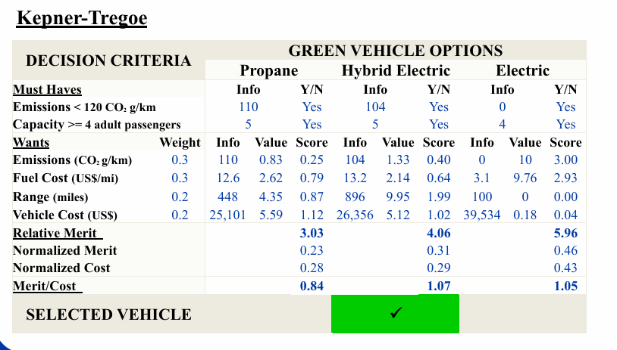

PETG was selected as the primary structural material for the ROV due to its manufacturability and repairability. PETG passes all the environmental screening with corrosion resistance, minimum temperature, and with its quick manufacturability it allows for great iterative development and prototyping at a low cost.

Integration and System Compatibility
Requirements:
- The ROV frame must contain at least 1 point of attachment for each required accessory.
- The ROV must have 5 independently removable subsystems.

PETG has very straightforward integration with easily manufacturable (3D printing) embedded channels and mounting bosses, which reduces part count and fastener complexity. It is also easily threadable, no galvanic corrosion, and bonding which allows for thrusters, the enclosure, and floatation elements,

Safety
Requirements:
- The ROV must use 0 conductive materials near open electronics.
- The ROV must use 0 toxic materials for all surfaces handled by team members.
- All materials must be skin-safe for all surfaces handled by team members.
- The ROV must have 0 sharp edges.

PETG can be manufactured with all sharp edges fileted, avoiding any sharp edges. Not only that, it is also non toxic and skin safe, meeting those requirements. Finally, it provides inherent insulation, reducing the hazards associated with electricity.

Chemical/Physical Deformation
Requirements:
- The float materials must experience 0 physical or chemical changes in saltwater or salt brine pool environments for the length of the project timeline.
- All external materials must be rated to a depth of at least 7 meters.

PETG can be easily coated to ensure chemical resistance to saltwater. It does not corrode and faces no galvanic degradation. Over the duration of testing/competition, the ROV will operate in shallow-water conditions and will not experience plastic deformation when the geometries are designed well enough, and can be met through proper design, rather than a reliance on material alone.

Repairability and Manufacturability
Requirements:
- All wear items must have at least 1 spare.

Repairability and Manufacturability are critical due to the testing environment and development process. As a first time team with little to none experience, making rapid repairs and iterations are essential which make PETG a perfect candidate.

Buoyancy
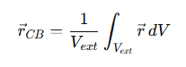
Only external geometry matters, the internal air cannot shift the CB unless external shape changes, would mass

